OPEN ENDED 3

Q: At what percent has Fetch grown year over year?

Assumption: To determine the percentage growth of Fetch year over year I am choosing the following metrics to measure

* What is the total sales amount yearly
* What is the total number of scans/transactions occurring quarterly over yearly
  + Since the data does not extend historically we the following metrics would suit the answer [SELECT count (DISTINCT strftime('%Y', scan_date) )

FROM TRANSACTION_TAKEHOME;]

* How many new users have signed up for Fetch yearly, percentage increase, quarterly
* How the reach of fetch has changed yearly by state

-- first we try to find out how many new users are signing up quarterly and then yearly

WITH user_quarterly as (

SELECT

*,CAST(strftime('%Y', created_date) AS Integer) AS year,

--to make future calculations simple we should case the year as an integer

CASE strftime('%m', created_date)

WHEN '01' THEN 'Q1'

WHEN '02' THEN 'Q1'

WHEN '03' THEN 'Q1'

WHEN '04' THEN 'Q2'

WHEN '05' THEN 'Q2'

WHEN '06' THEN 'Q2'

WHEN '07' THEN 'Q3'

WHEN '08' THEN 'Q3'

WHEN '09' THEN 'Q3'

WHEN '10' THEN 'Q4'

WHEN '11' THEN 'Q4'

WHEN '12' THEN 'Q4'

END AS quarter

FROM USER_TAKEHOME

),

--we create a view of just the year and the counts of accounts created for clarity

yearly_count AS (

SELECT year, COUNT(id) As y_count

FROM user_quarterly

GROUP BY year)

--we calculate the percentage increase

SELECT y1.year, y1.y_count, CASE WHEN y2.y_count IS NULL THEN 0 ELSE ((y1.y_count - y2.y_count) * 100.0 / y2.y_count) END AS percentage_increase

FROM yearly_count y1 LEFT join yearly_count y2 on y1.year = y2.year + 1;

--Here we can see the percentage increase in the number of users yearly has fallen in 2023 and 2024.

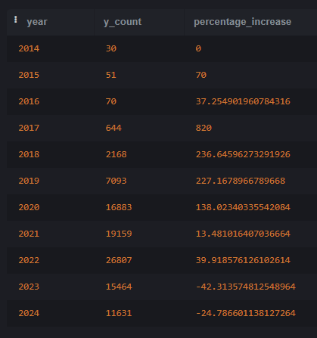

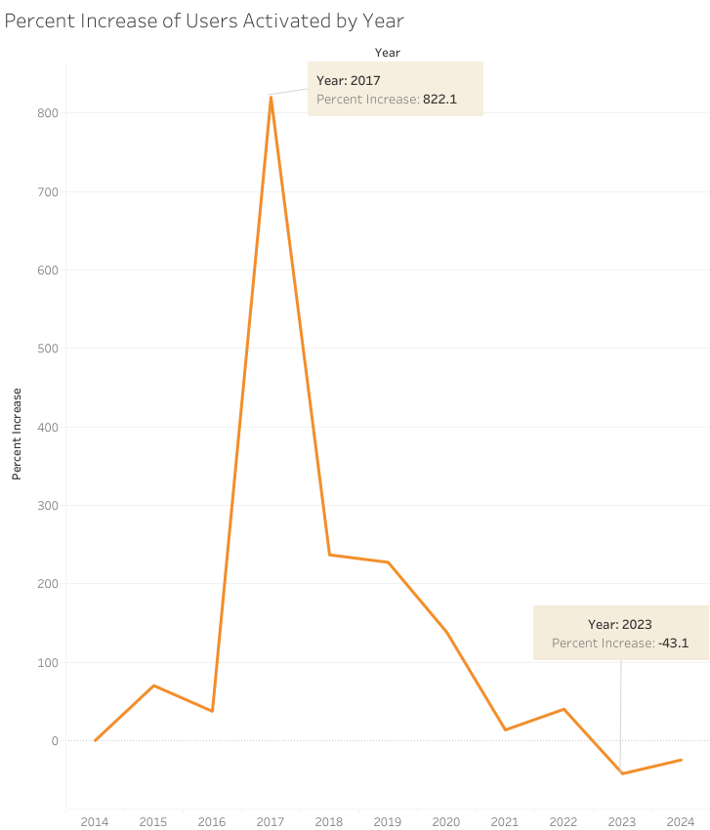

-- we can dig a little deeper here to see when the user counts fell off by calculating the growth quarterly

users_int_yq AS (

SELECT year, CAST(quarter AS Integer) as Q, COUNT(id) as user_count

FROM user_quarterly

GROUP by year,q)

-- I would ideally use lag and over window functions here, however this version of sqlite doesn't support window functions

SELECT

curr.year,

curr.q,

curr.user_count,

prev.user_count AS prev_user_count,

CASE

WHEN prev.user_count IS NULL THEN 0

ELSE (curr.user_count - prev.user_count) * 100.0 / prev.user_count

END AS percentage_increase

FROM users_int_yq AS curr LEFT JOIN users_int_yq AS prev

ON (curr.year = prev.year AND curr.q = prev.q + 1)

OR (curr.year = prev.year + 1 AND curr.q = 1 AND prev.q = 4) --for dec to jan of the next year

ORDER BY curr.year, curr.q, percentage_increase;

--we see here that the number of users activated stopped the upward trend around Q4 in 2022 and that continued onto 2023. However it turned around in 2024.

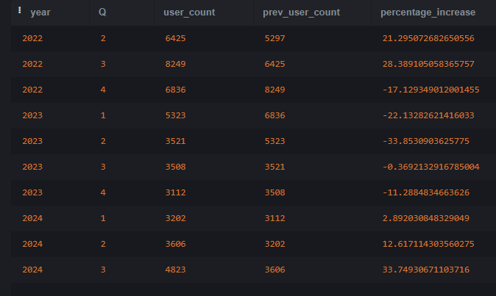

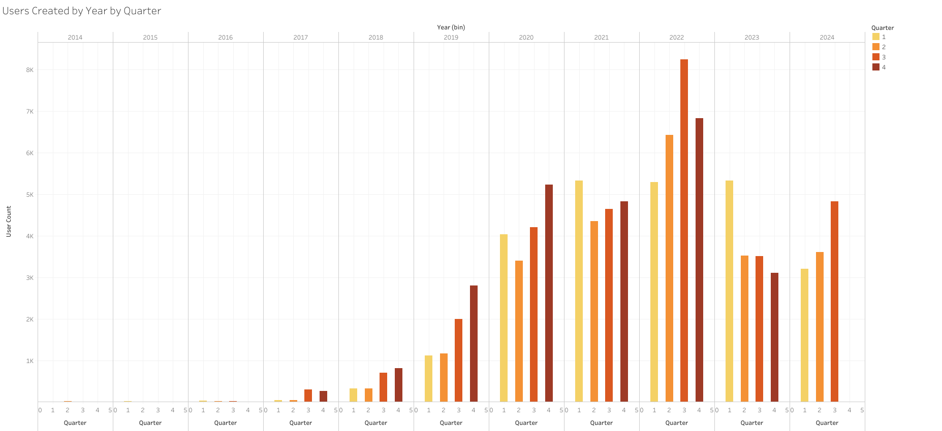

--when we examine user activation by state we can see that for the initial years user did not input the state and a majority of the state is NULL

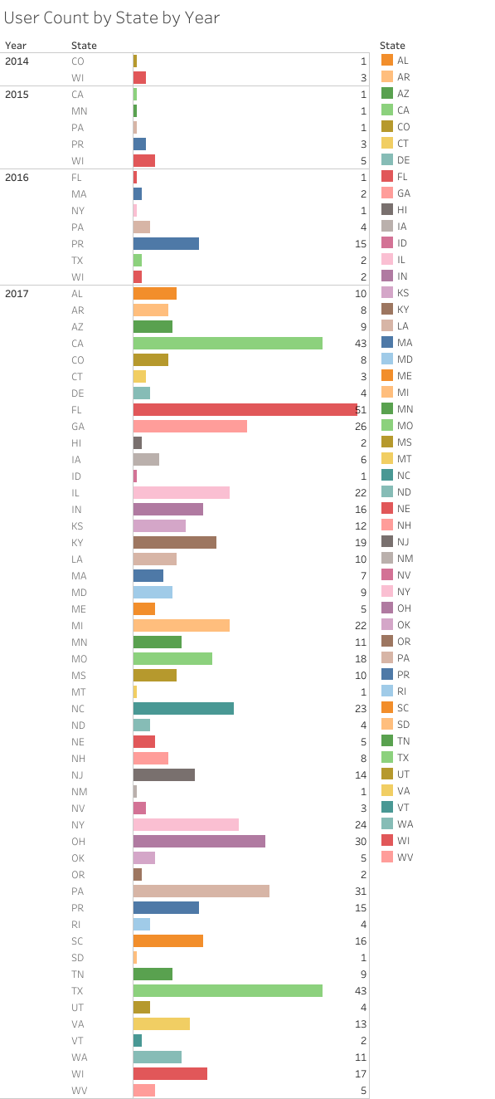 - this might be a user error, this is a data quality issue that can be resolved

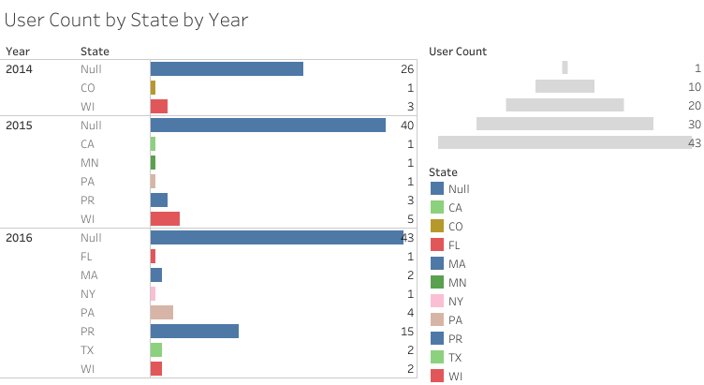

-disregarding the Null the early adoption was impressive

--the north and mid-west states were early adopters, with 2017 being a great country wide adoption.

-- we also see that Florida, Texas and California are the states with the most amount of user, as an added next step we can control for the population of these states to understand the growth better as these are densely populated states

-- here we can see the growth in Florida Yearly. It matches the overall trend of a drop in user growth for 2023, California also matches the overall trend

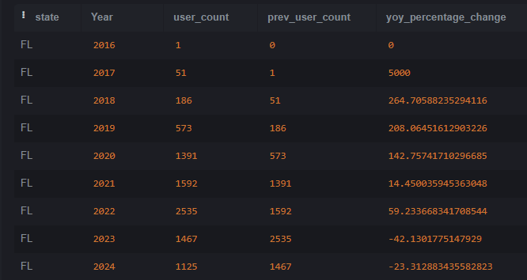

--The interesting thing to note is that while all the states had negative growth in 2023 the NULL state had a positive growth, we should work to reconcile the data to get state information on all the users.

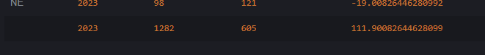

--with a little more time I would continue this analysis to see how is the user growth by generation, and gender.

-From this analysis it seems that Fetch had a rough year in 2023, but is on the path of recovery as of Q3 2024.